Session-2

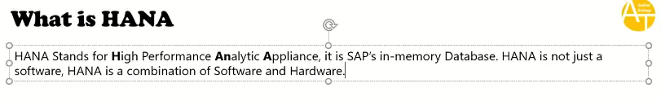

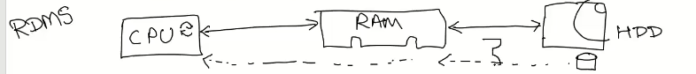

RDBMS: takes lot of time to get the data from harad disk,

1. Get data from HARD disk nd place it into the Ram and then access those records.
2. Primary store is hard disk.

HANA:

1. Primary store is RAM.

Compression: Compress the data and store, remove the redundancy data.

Data Aging: if there is a data that is not updated/deleted/inserted at all or last 10 years no body use the data in analytics report or any transactional reports, perhaps should not keep the data in RAM, those data move to the hard disk.

RAM- warm store

HARD Disk: Cold Store.

Insert Only Approach: whenever update the data very expensive, you never update any data or never delete any data, you would just insert the data there is a change in the data.

Delta store has majority of data is updated. Key is <DB key> and <Time stamp >.

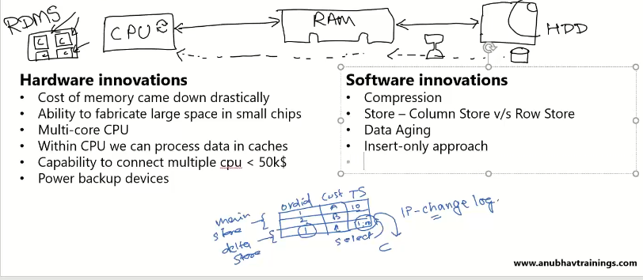

Row Store Vs Column Store

Row store : data stores at consecutive memory location.

Delta store is row store, table is updating very frequently ultimately working with row store.

* Actually scan all the records.

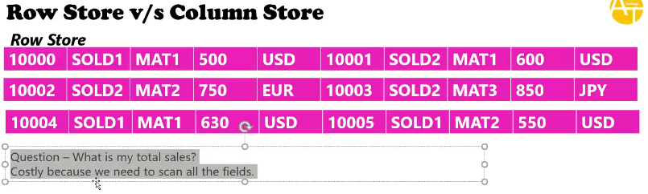

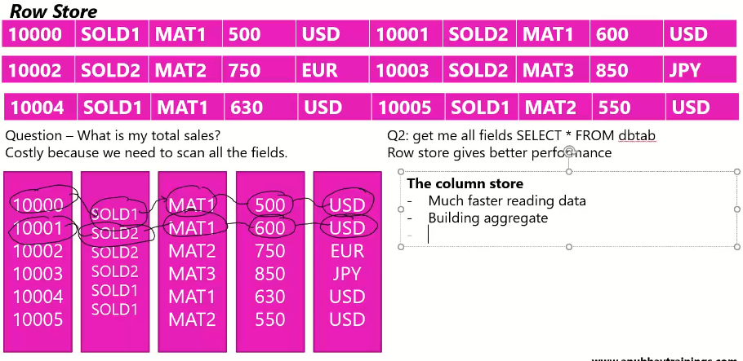

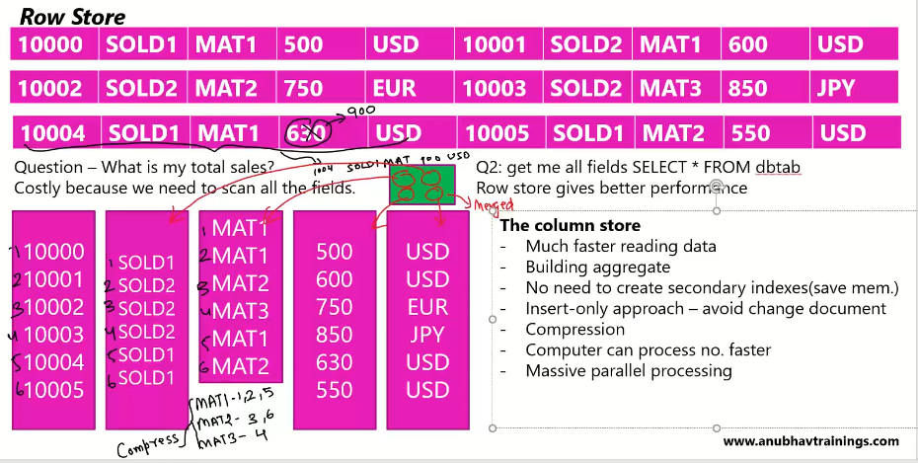

When Choosing the Row Store Vs Column Store:?

* Compresion is good when more the repeated values.

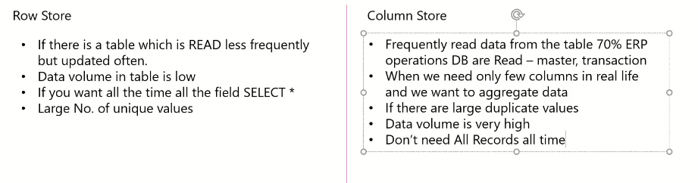

52:00

No more concept of pooled and cluster tables.

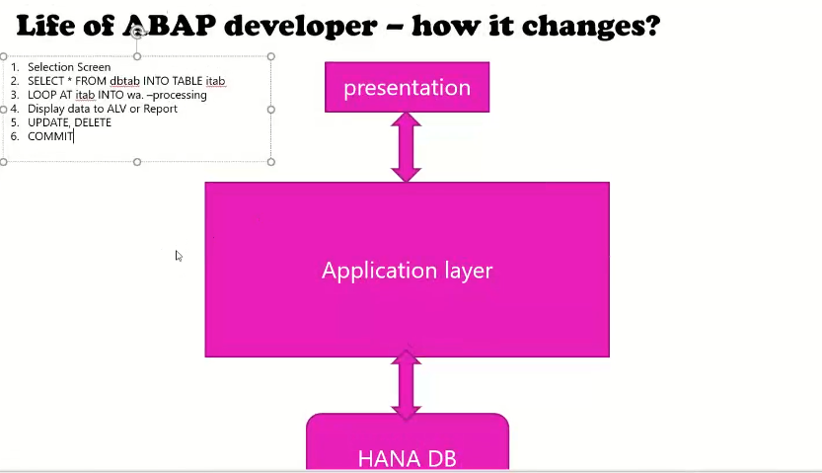

HANA DB more costly compare to other DB, it has involved Hard ware and software components.

Most of the processing is done in the HANA DB only.

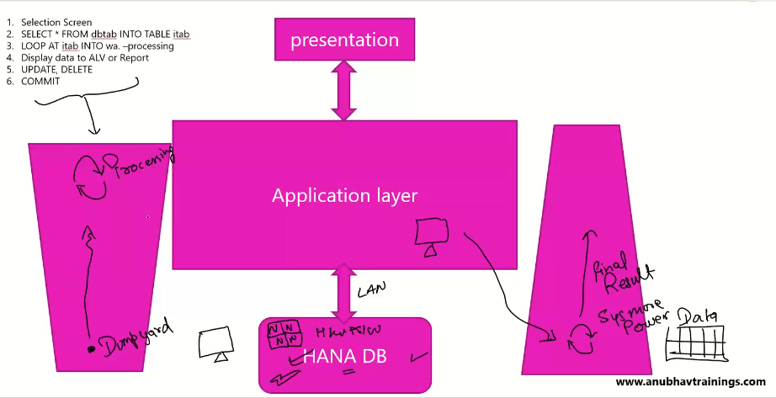

01:00:00

Code- to- data- paradigm:

Ans: we are try to push down data intensive logic into the data base.

Core to data paradigm :we should try to push down data intensively logic into the data base.

Table is updating frequently that is always the row store…. Only. You always choose the row store.

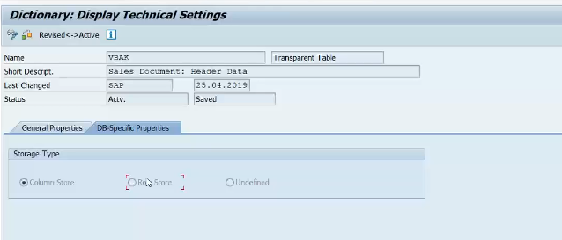

🡪change the it as column to row and row to column.

🡪if you change it row store, you will get the proper data, not giving any dump/syntax errors but impact on performances.

🡪you can use it select \* for column store 🡪 it is impacting to the system with bad performances issues.

🡪SAP has given the options only, you can follow or obey this, it is not impacting your code…

HANA Comes to the picture, How?

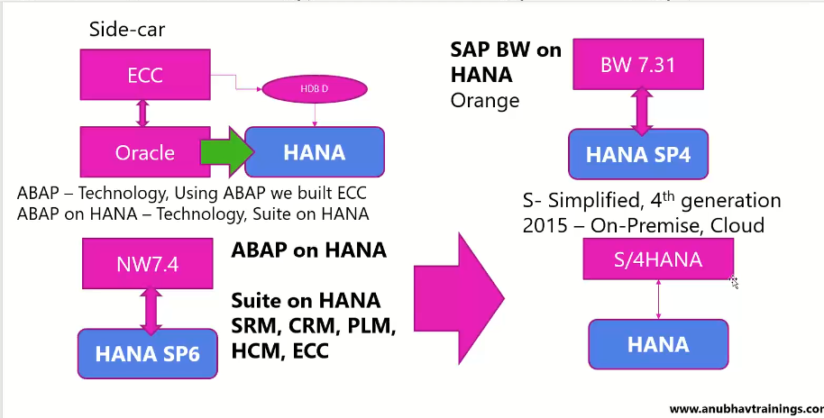

Hana Driver: HDBD: is nothing but a connection.

HDBD: Hana Data Base Driver.

Hana is running parallel to oracle.

On-premise 🡪 for customer, need to setup own hard ware/ software etc..

S4HANA: is the solution released by 2015 in two flavours, on-premise and cloud.

S4HANA- built on technology ABAP on HANA.

HANA Architecture:

Components inside HANA:

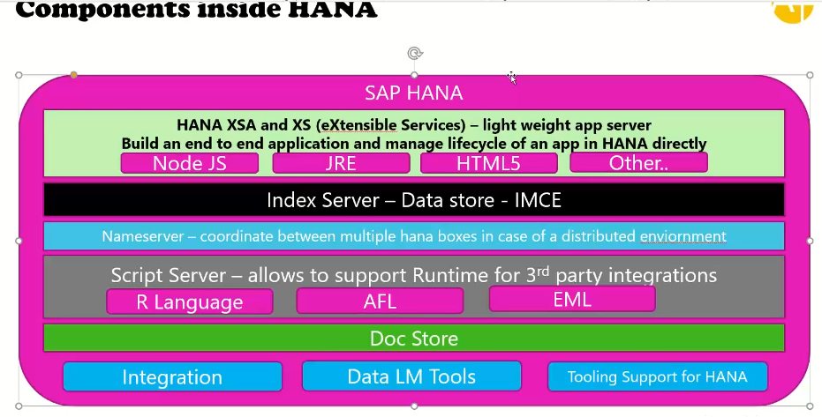HANA Does not support ABAP engine, that is still in net weaver system only, to run abap application in SAP hana we need the net weaver system.

SAP HANA(XSA) supports open source language(Node JS/JRE/HTML… ) except ABAP.. Because customer has taken only HANA, not the ABAP..

Index Engine:

* In memory computing engine(IMCE)
* Store the data.

Name Server:

* Large companies they had the massive data and they have the big systems, we need SAP HANA boxes .
* Name server is connecting between the inter hana boxes.
* Co-ordinate between multiple hana boxes.

Script Server:

AFL- Application Function Library.

EML: External Machine Learning Library

Doc Store:

* Store the Documents like pdf/word/xlsx.

.

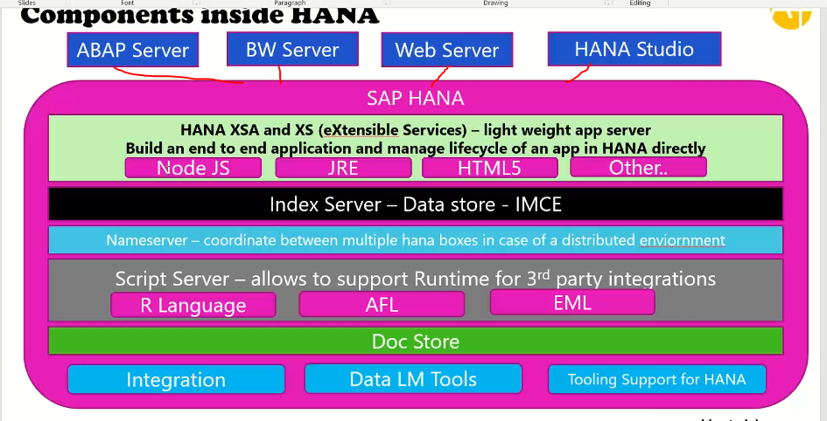

Index Server:

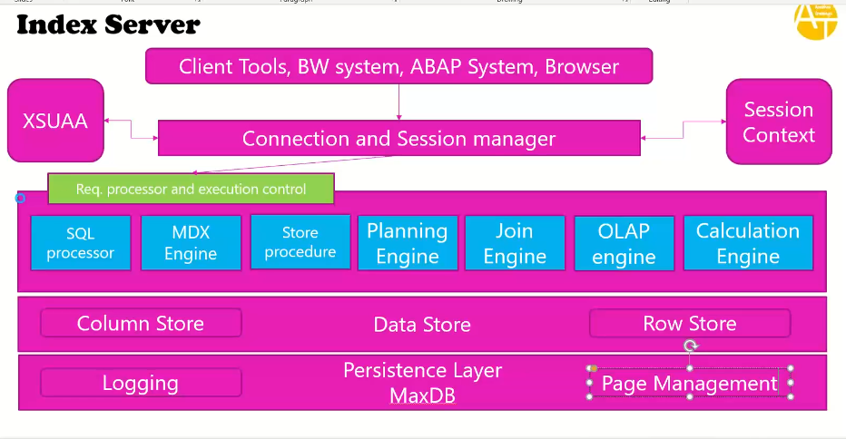

Connection and session manager : listening the request.

XSUAA: HANA access user account and administrator.

* Used for validating the user id and password .
* Used for authentication

Session Context: who are connected currently my hana box.

Request Processor and Execution control : like dispatcher in abp.

* Sql processor –to execute the sql commands.
* Store Procedures :

Data Store: actual data to store.

MaxDB: used for backup and recovery purpose.